Linear Regression



Bordeaux, France 

Bordeaux Wine

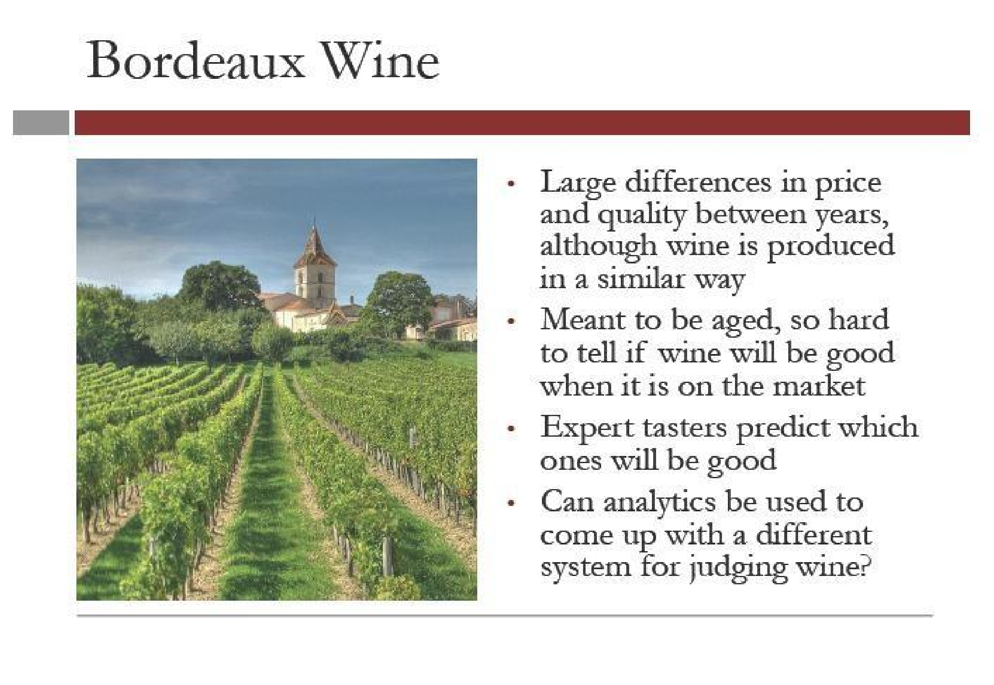

Predicting the

Quality Of Wine

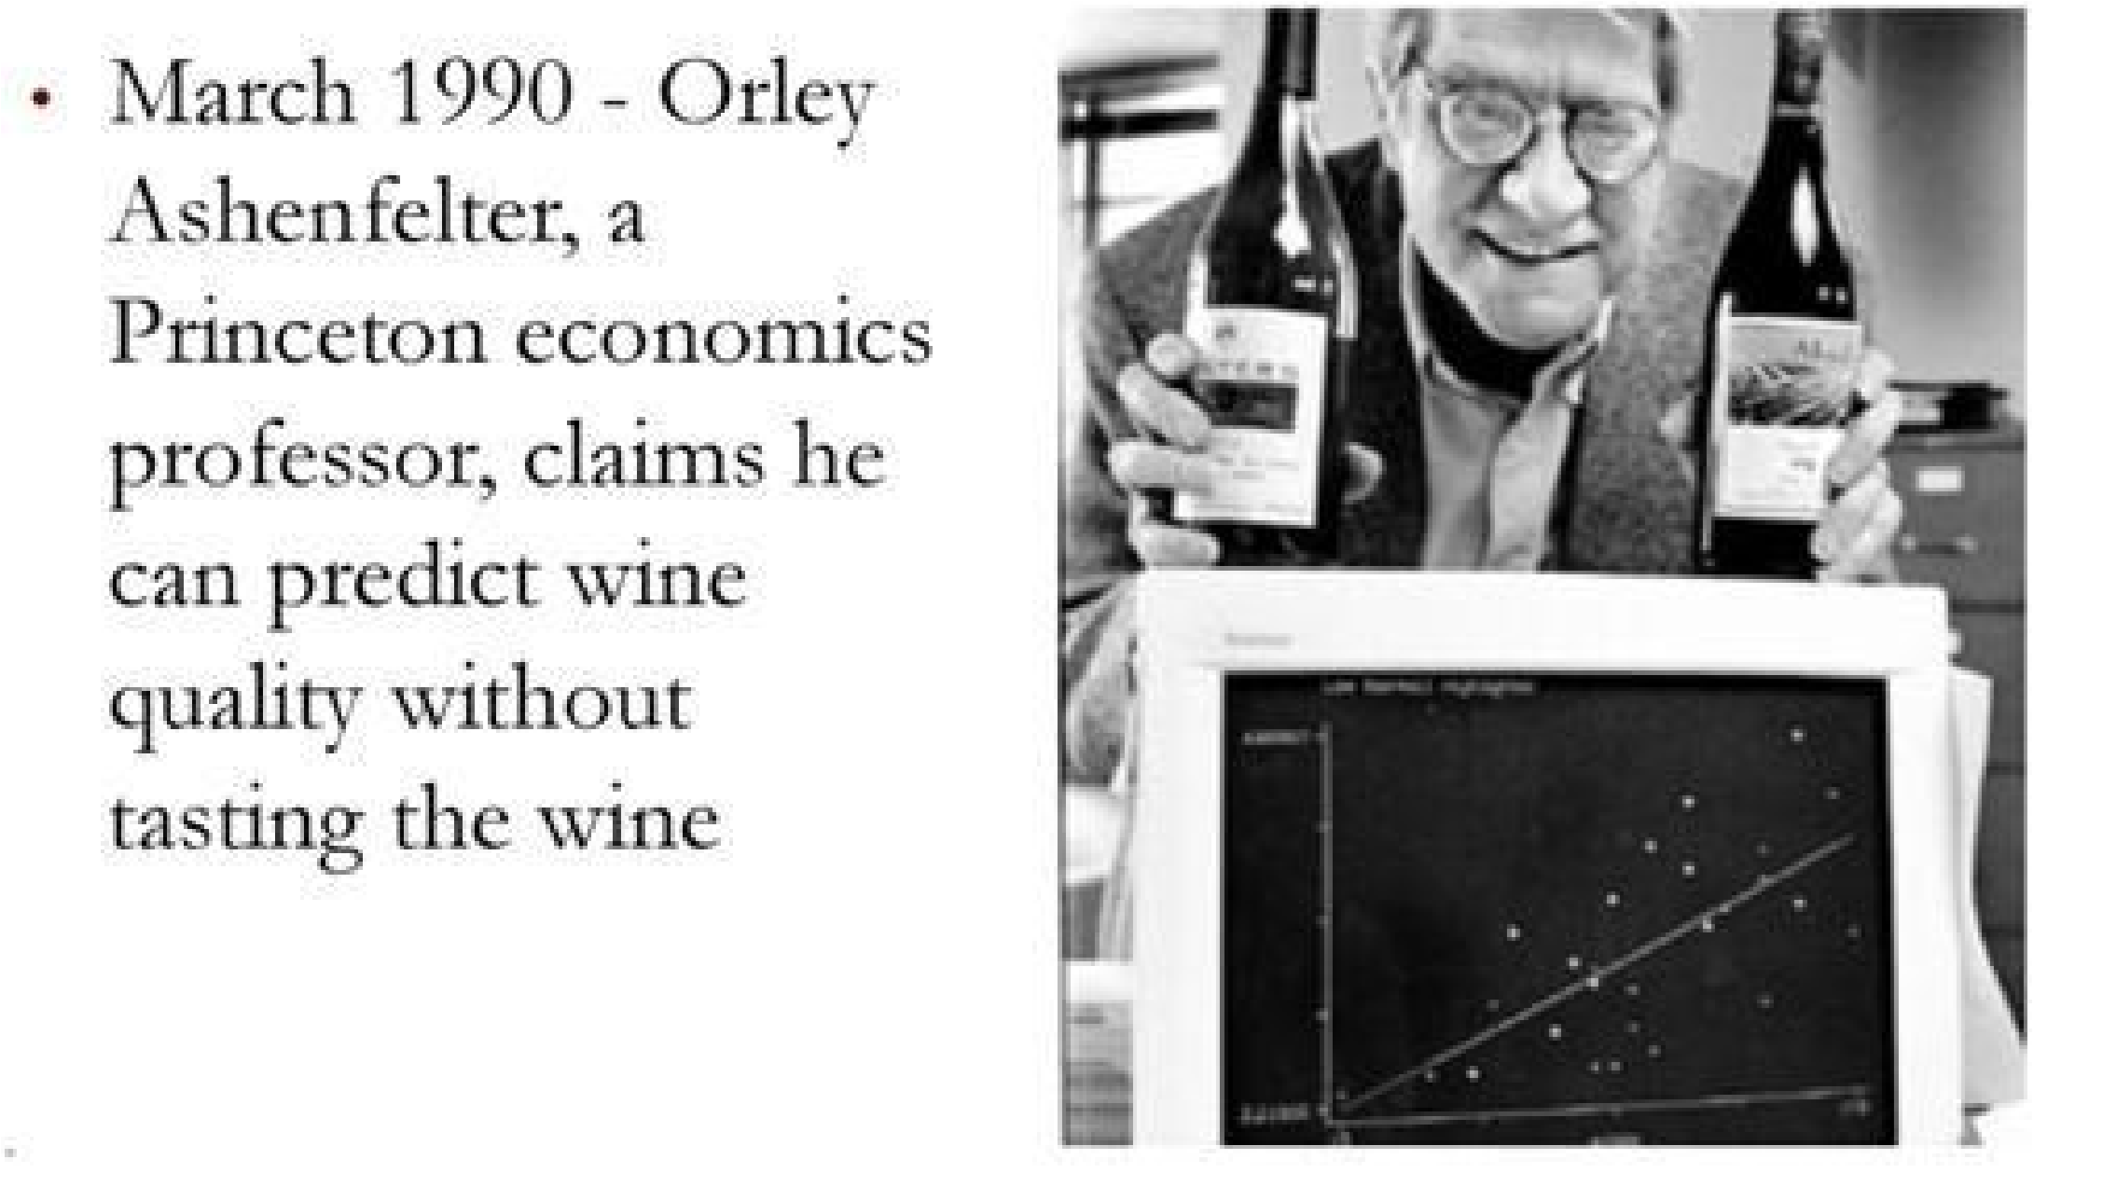

<https://storage.googleapis.com/dimensionless/Analytics/wine_test.csv>

<https://storage.googleapis.com/dimensionless/Analytics/wine.csv> 

Building the Model

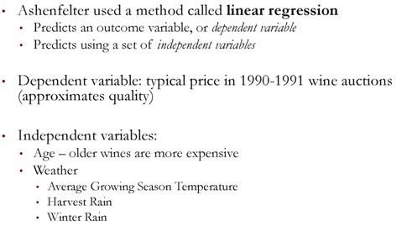

The Data(1952-78) 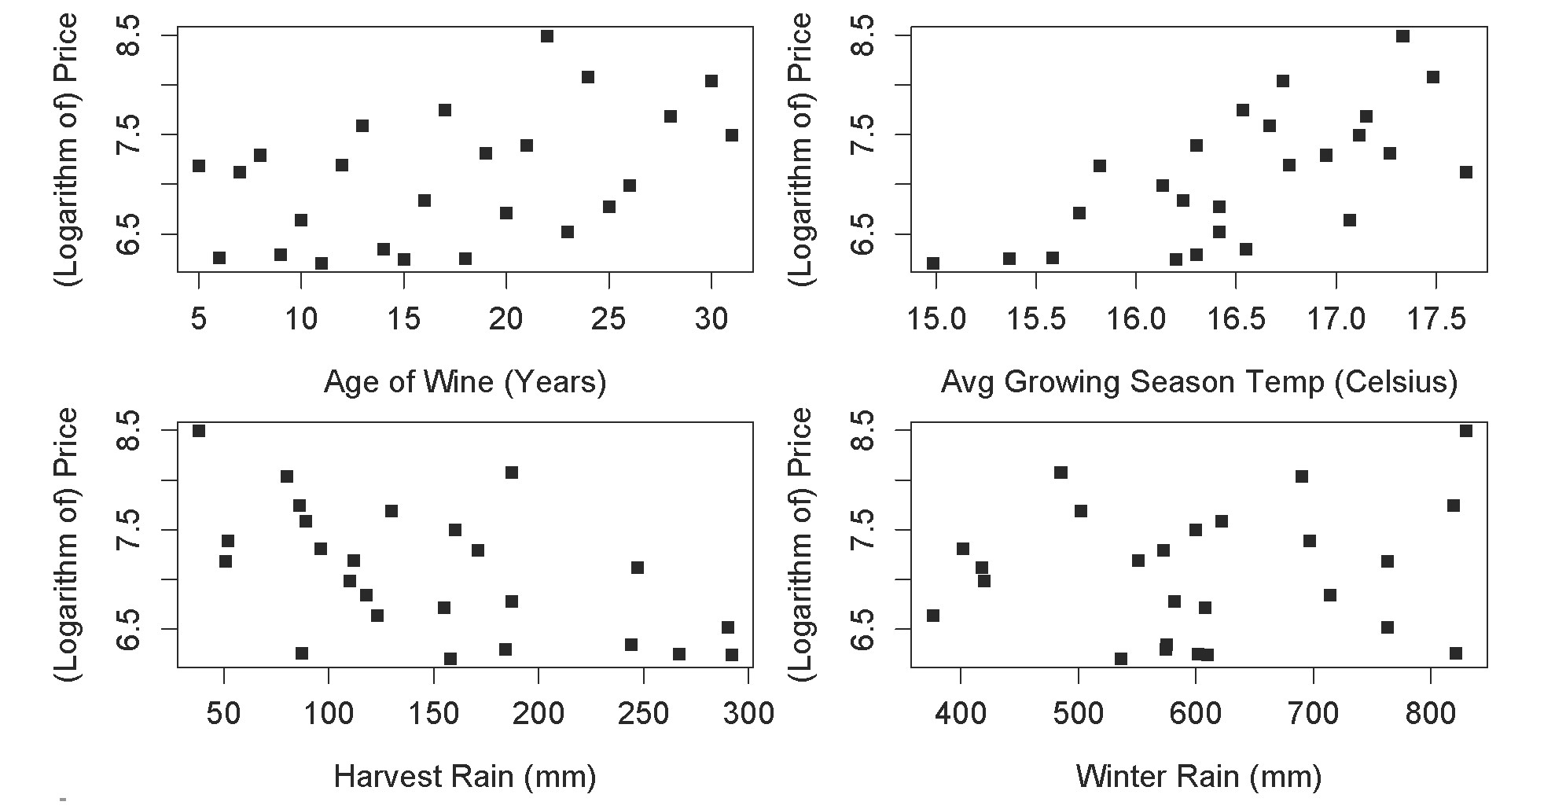Expert Reaction 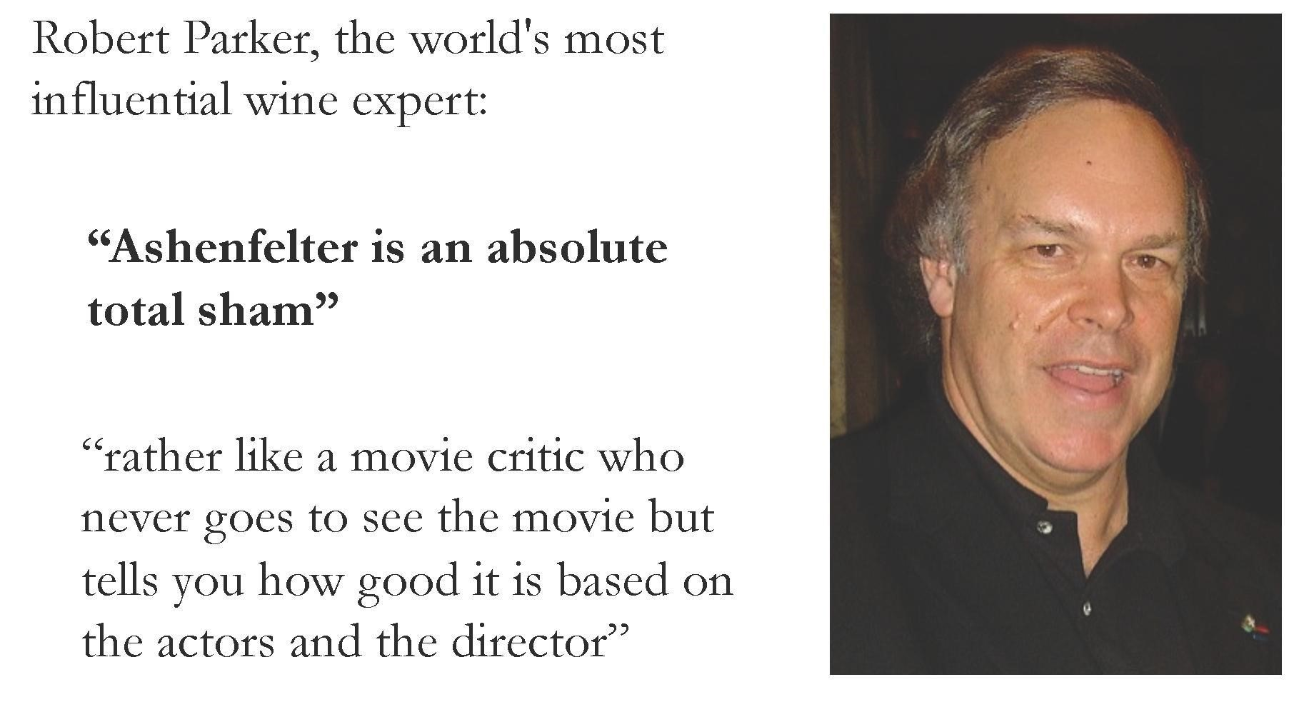Quick Question

The plots below show the relationship between two of the independent variables considered by Ashenfelter and the price of wine. 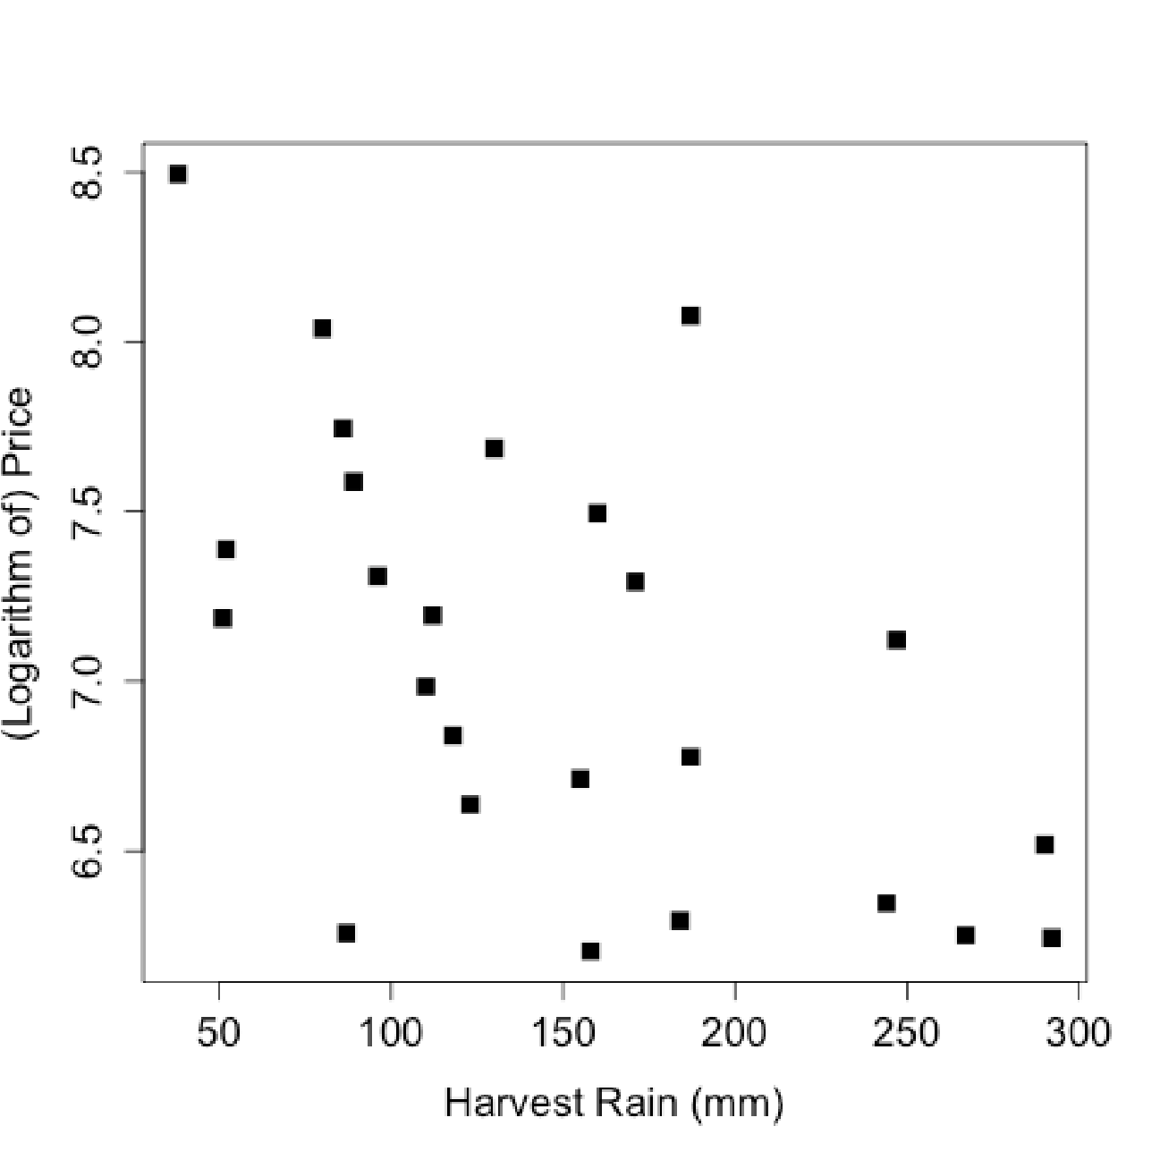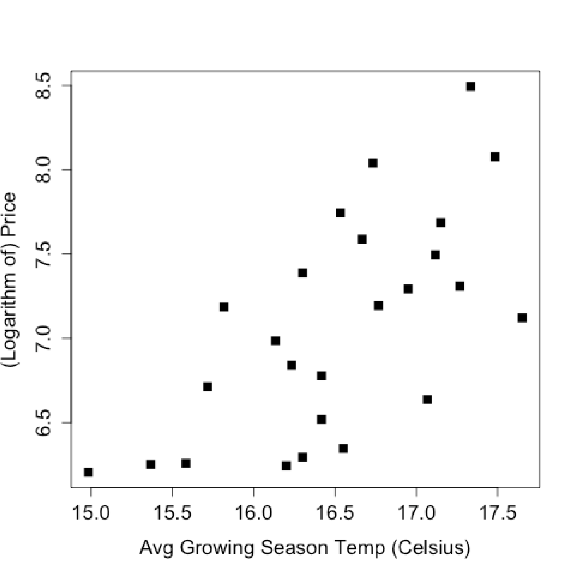

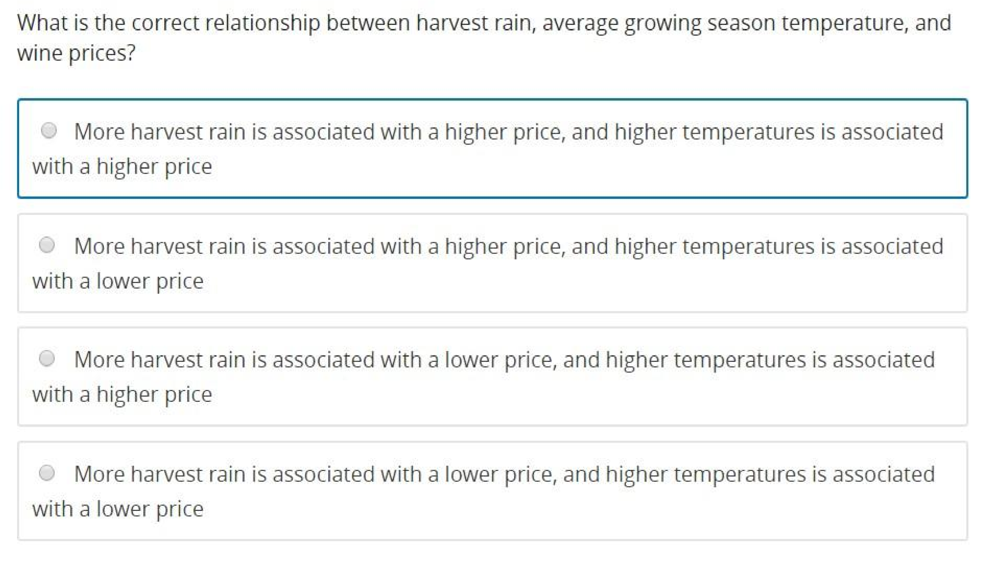

One Variable Linear Regression

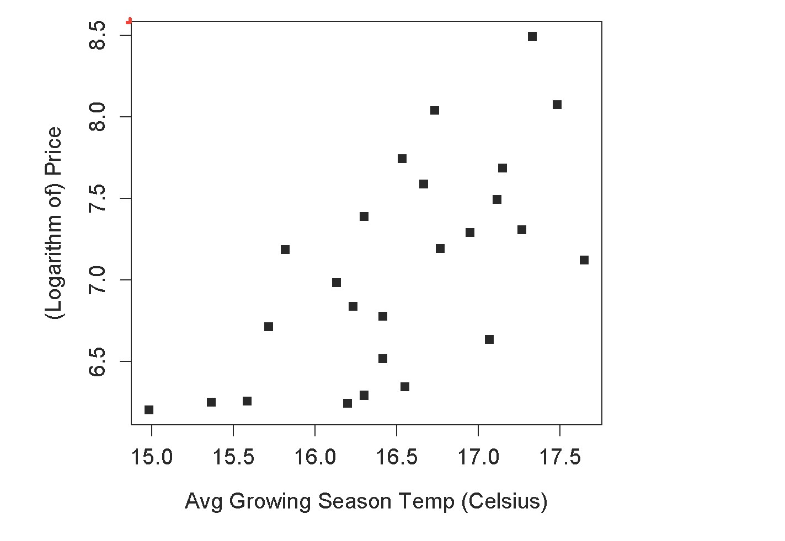

The Regression Model 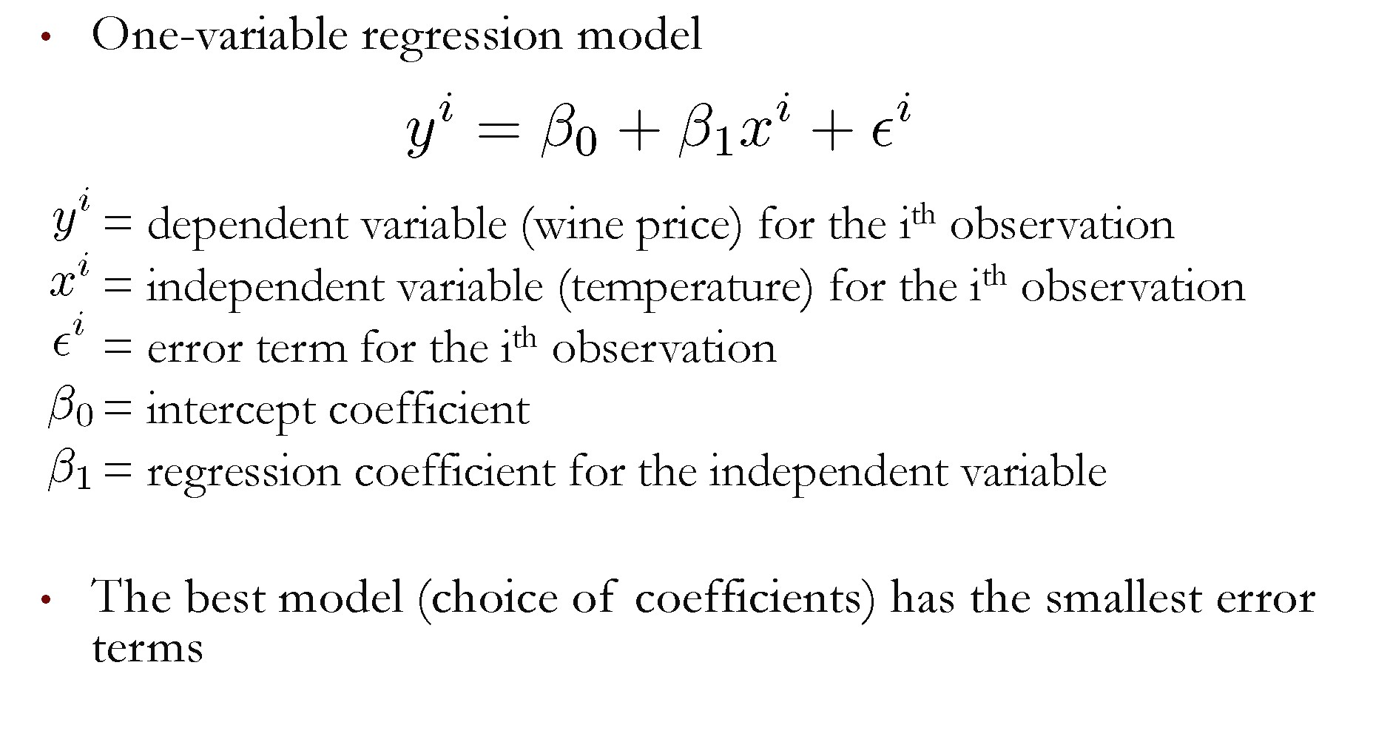Selecting the Best Model 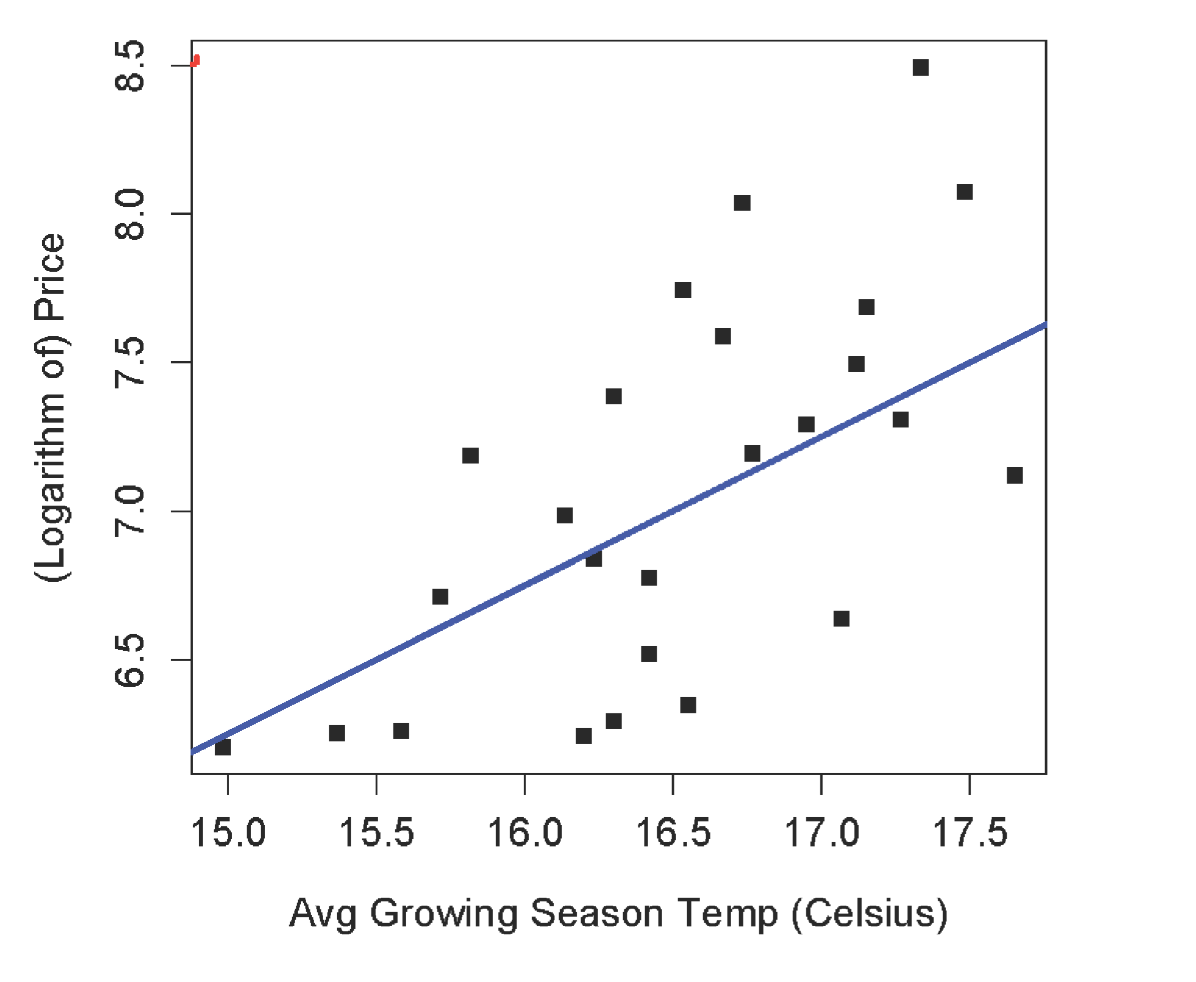Selecting the Best Model

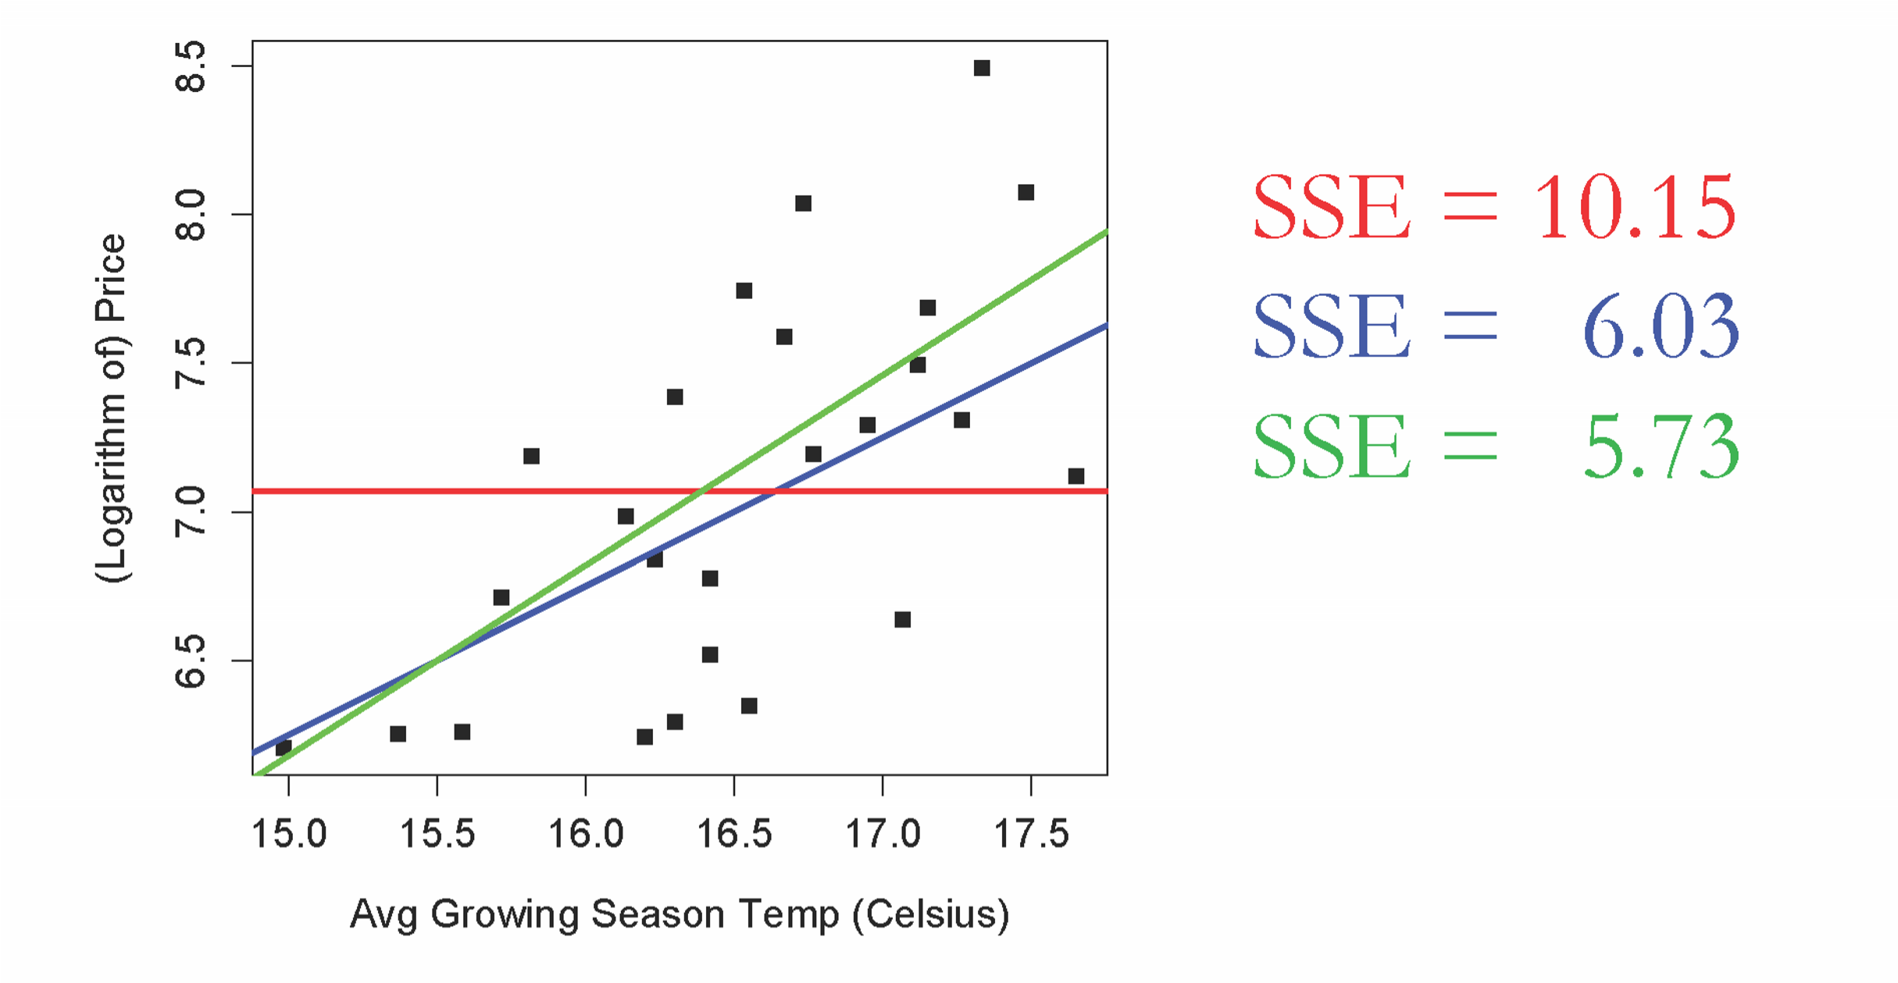

Other Error measures 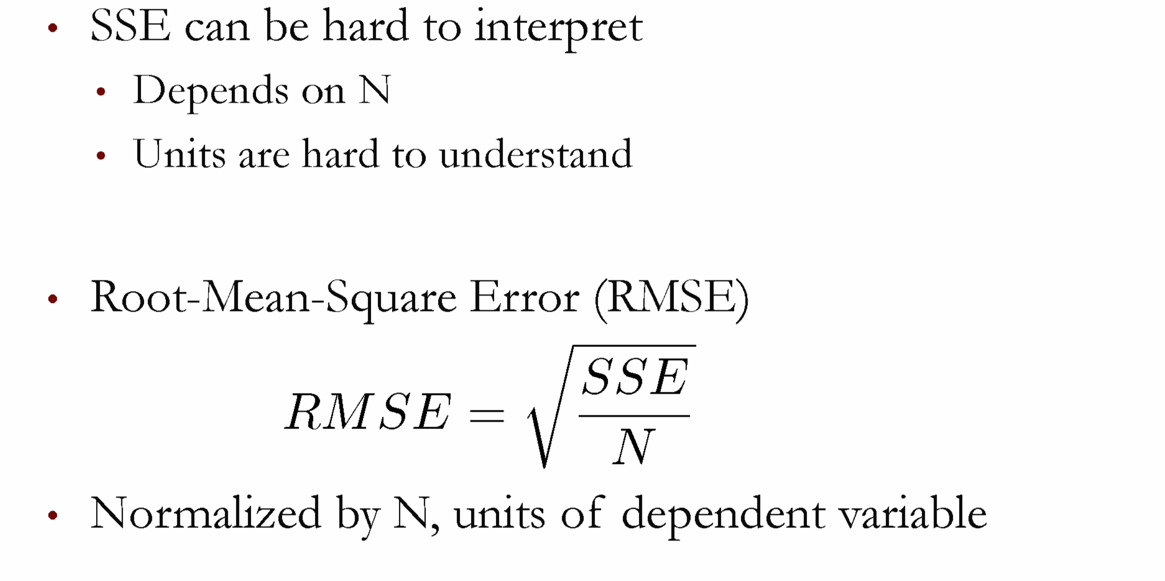

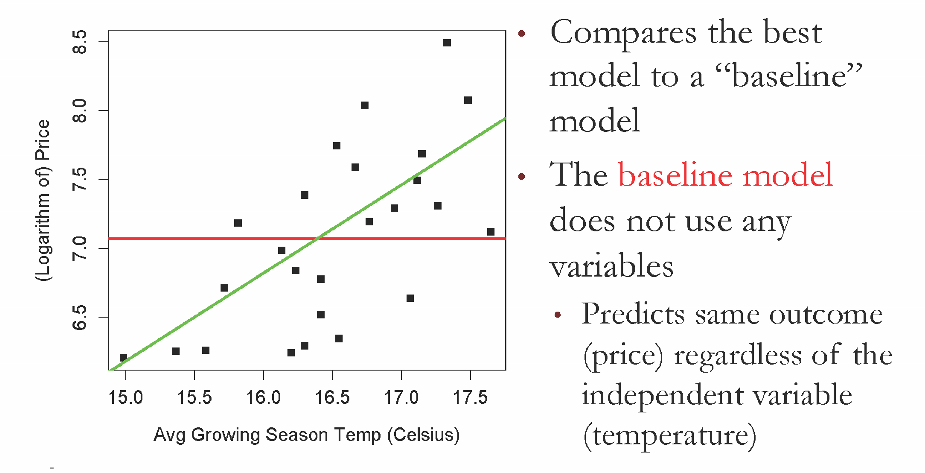

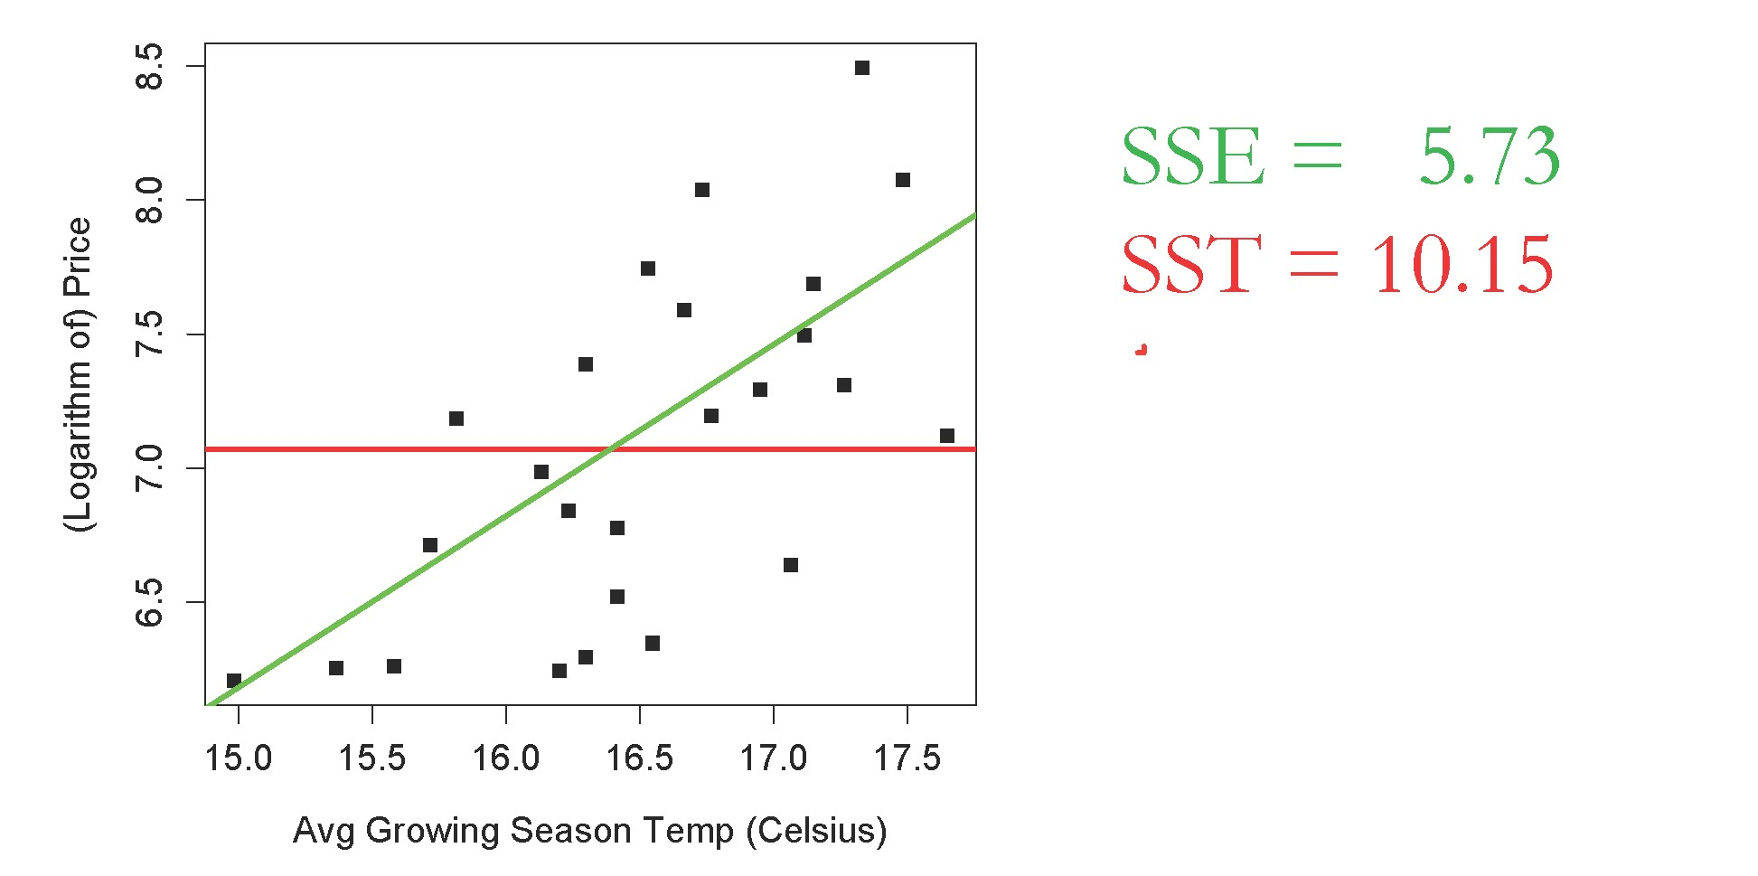

Interpreting R2

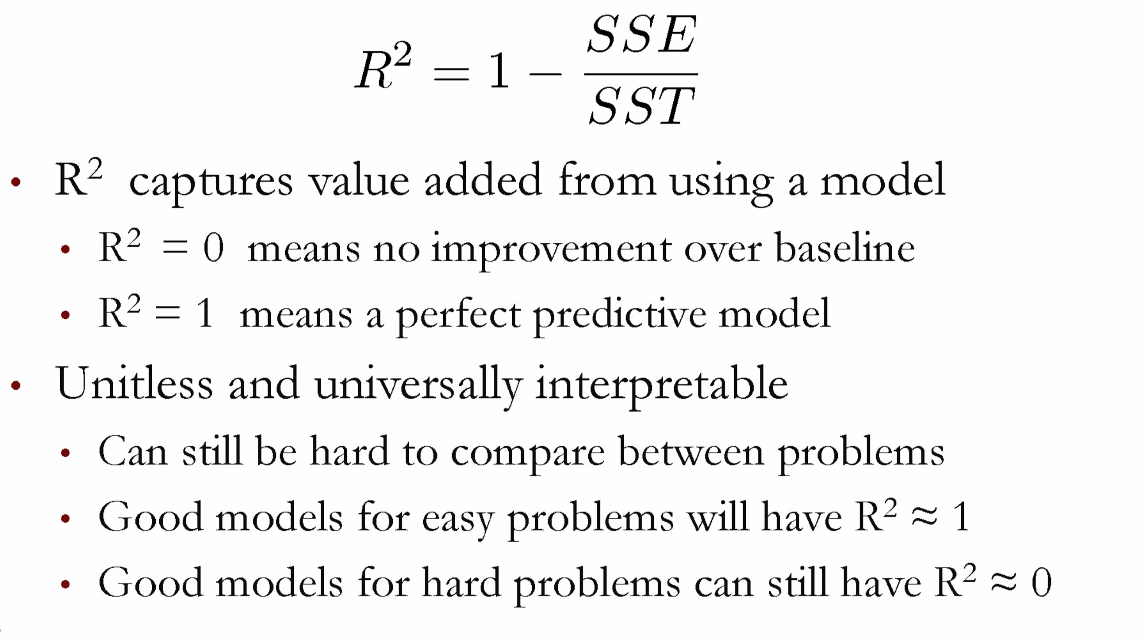

* The following figure shows three data points and the best fit line 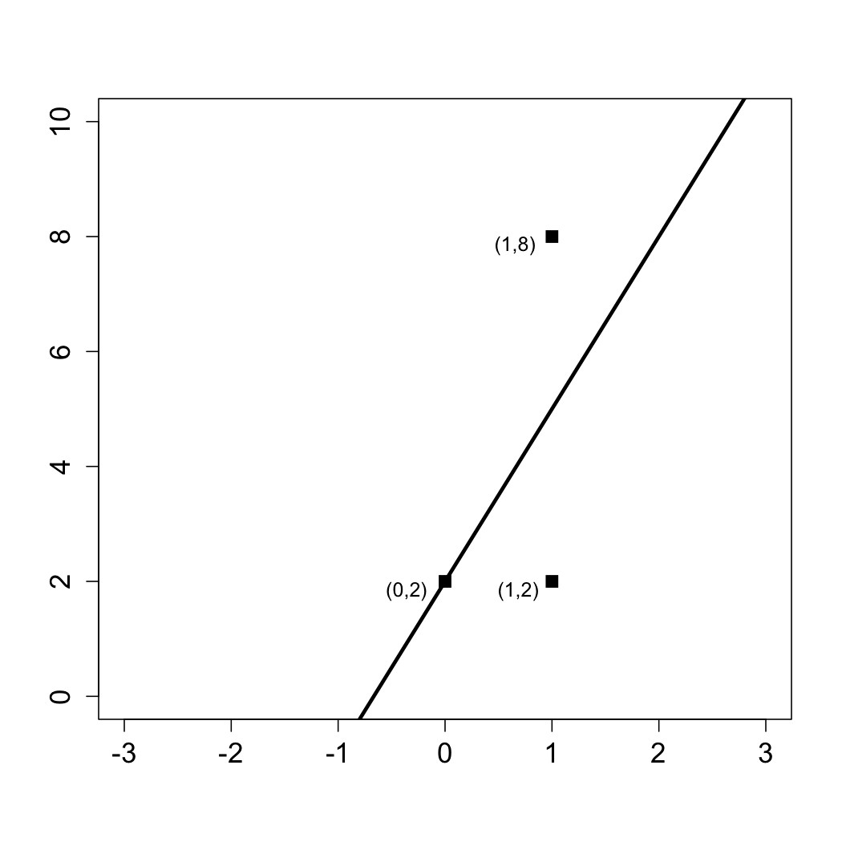

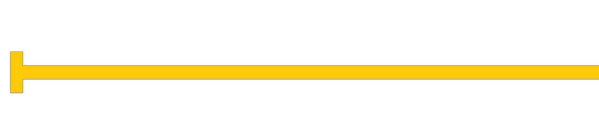

Quick

Question

* y = 3x + 2.
* The x-coordinate, or

"x", is our independent variable and the y-coordinate, or "y", is our dependent variable. 

Quick Question

▪ Please answer the following questions using this figure.

* What is the baseline prediction?
* What is the Sum of Squared Errors (SSE) ?
* What is the Total Sum of Squares (SST) ?

What is the R² of the mo